### Diabetes Insipidus

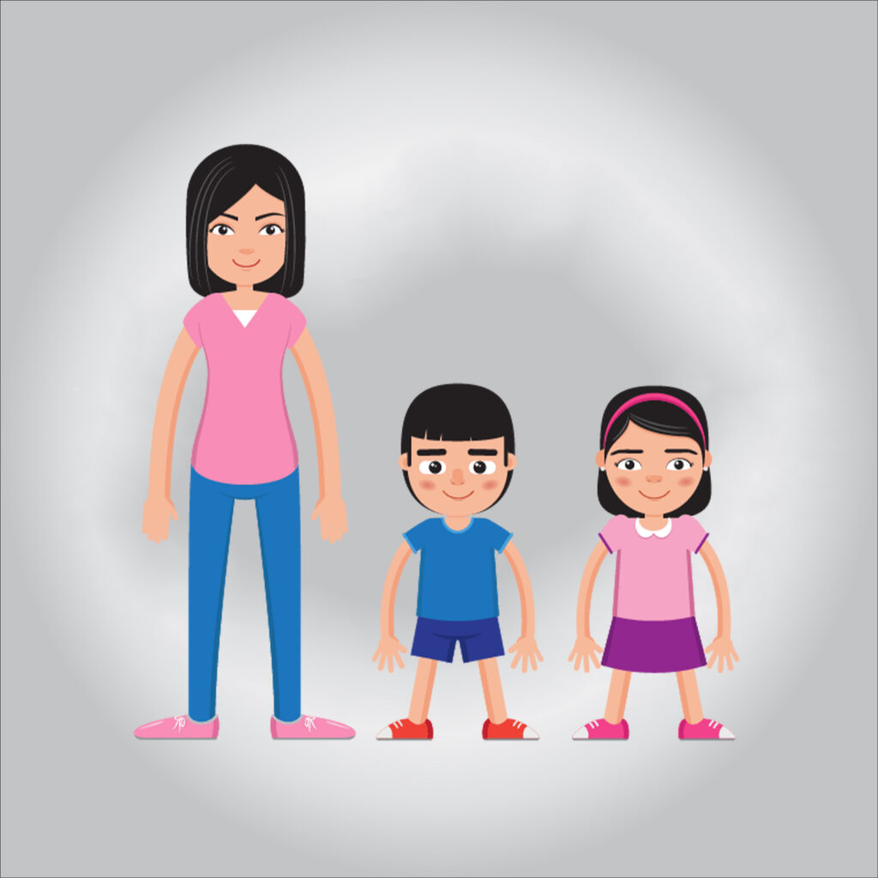

#### **Diabetes insipidus**

**Diabetes insipidus is an uncommon disorder that results in an imbalance of fluids in the body. This imbalance leads to the production of large amounts of urine. It makes you feel very thirsty even if you just drank.**

#### **Symptoms**

**Signs and symptoms of diabetes insipidus include:**

**Extreme thirst**

**Passing large amounts of pale-coloured urine**

**Frequent need to get up to urinate at night**

**Prefer cold drinks**

#### **Causes of diabetes insipidus**

**Diabetes insipidus occurs as a result of a defect in the structure of the kidneys that makes them unable to respond properly to antidiuretic hormone. This defect may be caused by a genetic disorder or a chronic kidney disorder**

#### **Complications**

**Drought**

**Diabetes insipidus may lead to dehydration. Dehydration can cause:**

**Dry mouth**

**Changes in skin elasticity**

**Thirst**

**Exhaustion**

**Electrolyte imbalance, electrolyte imbalance**

**Diabetes insipidus can cause an imbalance of minerals in the blood, such as sodium and potassium (electrolytes), that maintain fluid balance in the body. Symptoms of an electrolyte imbalance may include:**

**Weakness**

**Nausea**

**Vomiting**

**Anorexia**

**Painful muscle spasms**

**Confusion**

#### **Diabetes insipidus treatment**

**This type is usually treated with a synthetic hormone called desmopressin (DDAVP and Nocdurna). This medication replaces antidiuretic hormone (ADH) and reduces urination. Desmopressin can be taken as a tablet, nasal spray, or by injection**